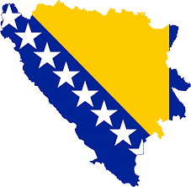
Contents:
- Brief History & What to Expect………2
- How to get there………3-4
- Useful Miscellaneous Information………5
- About Hrasnica………6
- About the Family………6
- What to do & see………7
- Health & Safety………8
- What to take………8-9
- Working with the children………9-10
- Activities………10-14
Bosnia Volunteer Information Pack

Oxford Aid to the Balkans
Registered charity number: 1104190
Email: oxabinfo@gmail.com
Website: http://oxab.yolasite.com/
Facebook: https://www.facebook.com/groups/2202771997/

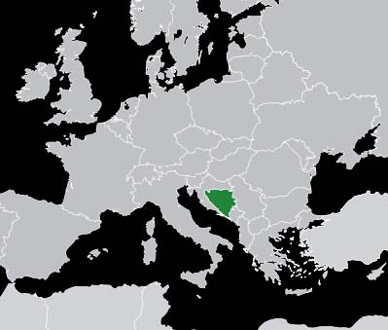 | Brief history
 | OXAB have been organising aid to refugees in and around Bosnia-Herzegovina (BiH) ever since the war in the early 1990s, and unlike many other charities, which have moved on to more recent flashpoints, we continue to help those affected by the conflict decades later. The country was torn apart by the war, with huge flows of refugees as communities with a mixed ethnic background were violently separated into their constituent groups, by various militias and armies engaging in “ethnic cleansing”. Needless to say, the war also resulted in the deaths of thousands of people, from all ethnic groups, leaving many people, including children, without family or friends. The need for aid continues to be felt by children growing up in a ravaged and very poor society. OXAB provides volunteers to run sessions in the community centre, without which there would be nothing for the children to attend during the holidays but also primarily to aid the children with their English learning.
What to expect:
The project in Bosnia is based at a community centre in Hrasnica, a suburb of Sarajevo. It has been running for over 10 years now (so the children are used to foreign volunteers coming in every spring and summer); and it is set up in a way that even if you only have two weeks to spare, you will be able to leave an impact. Volunteers will stay in a house owned by Nijaz who is the director of the community centre (about 3 minutes walk away). Nijaz is brilliant to work with and speaks enough English. The price for this is €8 per person per night with volunteers sharing a room on the first floor. You will have access to the family’s kitchen and their bathroom is fitted with a bath and a showerhead. Bedding is provided but you will need to bring your own towels. During the mornings on weekdays, volunteers organise sessions with the children, usually between 8 and 12 years old, and will have access to a classroom and the sports centre. Generally the sessions are run from roughly 10 am to 12pm (the times vary each year but it’s always a 2 hour shift in the late morning). During the afternoons volunteers are free to explore Sarajevo or, if they like, can provide more sessions for the children, even though Nijaz prefers you to work during the mornings only (largely due to keeping the children out of the hot midday sun). Beware of the end of Ramadan (August), which is a public holiday and might shorten your time available to work with the children. Also, children may also be returning to school in late August and so fewer will have time to go to the sessions.  Sarajevo can be easily reached by bus or tram, but there are also many walks in the nearby mountains, including to Tito’s old residence (a map is recommended), and a very long hike to the derelict 1984 Winter Olympics ski slope. | 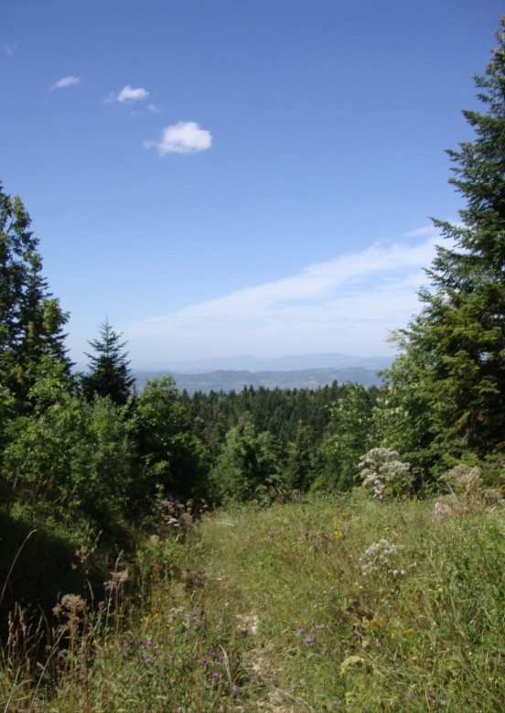 | 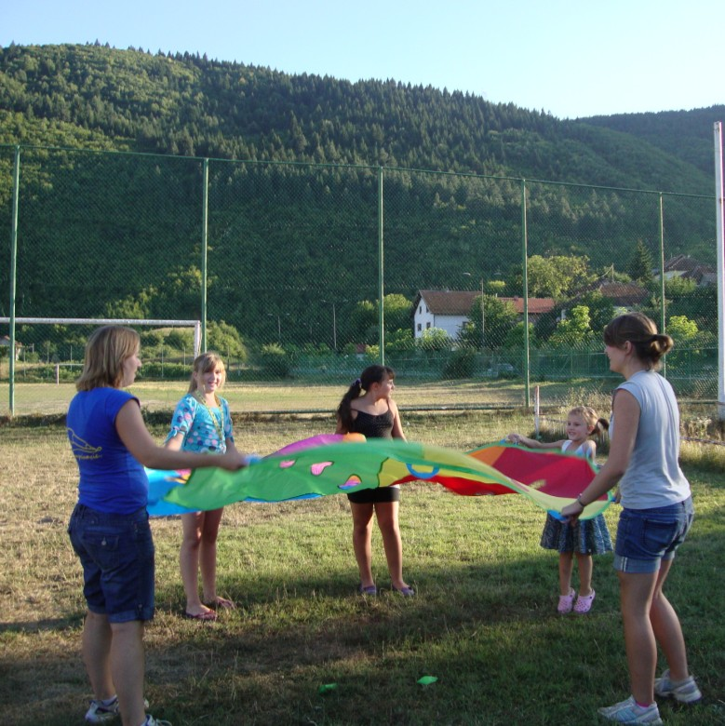
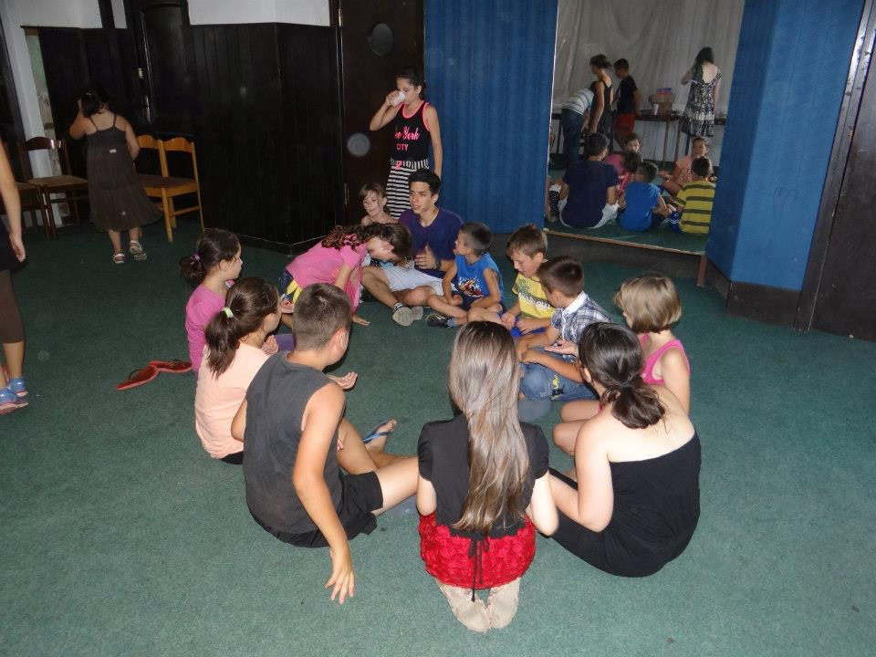
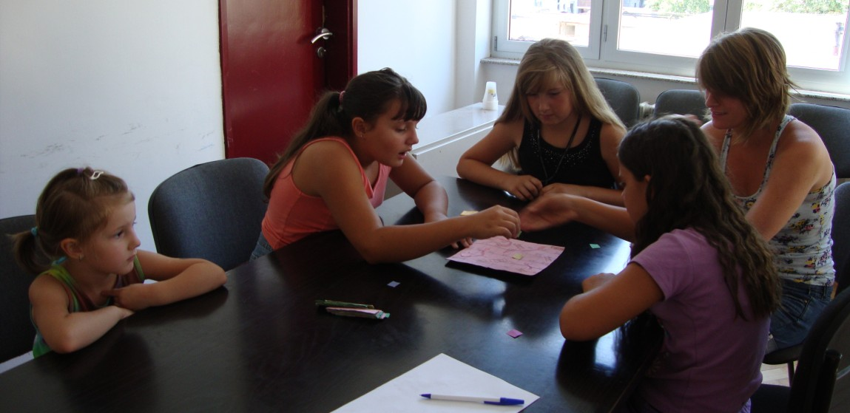

How to get there
One of the great things about travelling with OXAB is the flexibility it gives you with travelling. You may be combining your time volunteering with other travels (I can’t recommend a tour of Eastern-Europe enough, it is great fun – cheaper than the rest of Europe and very different, unique cultures to experience) so arriving at Sarajevo airport may not be the most convenient way to arrive. There is very rarely (if at all) a direct flight from any airport in England to Sarajevo. So your options are to either book connecting flights or to travel to a neighbouring country and take the coach to Sarajevo. Connecting flights are often much more convenient and less stressful, but unfortunately also more expensive and can be quite long – at least four or five hours from London to Sarajevo. The alternative is to travel to Sarajevo via coach from Croatia (Split or Dubrovnik), which takes about six-seven hours, through absolutely beautiful landscape (and flights to Croatia + the coach to Sarajevo can be under £100 in total). There are about two buses during the day and a night bus (EuroLiners) so ensure you leave elbow-room otherwise you’re in for a long wait. You may be expected to pay for baggage on public buses from Croatia to Bosnia (about 1.50 Euros, in local currency). The bus stations in Split and Dubrovnik are both located at the harbor; and there are storage facilities at the bus stations if you have time to explore one of the Croatian towns. Alternatively, it is now also possible to fly in with Wizz-Air to Hungary and then take the train in.

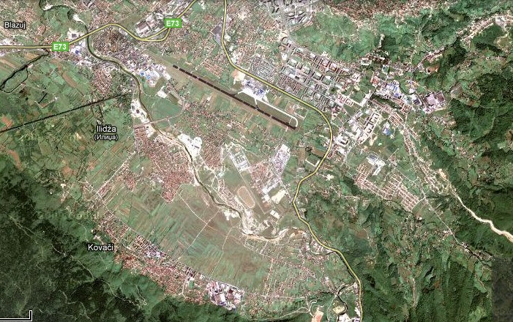 |  |  |  |  |  | Sarajevo  (Slightly north of the arrow)
 |  |  |  |  |  | Airport
 |  |  |  |  |  | Ilidza
 |  |  |  |  |  | Hrasnica
Map of Hrasnica  Bus-stop to Sarajevo Community Centre Nijaz’s House Sports Centre | 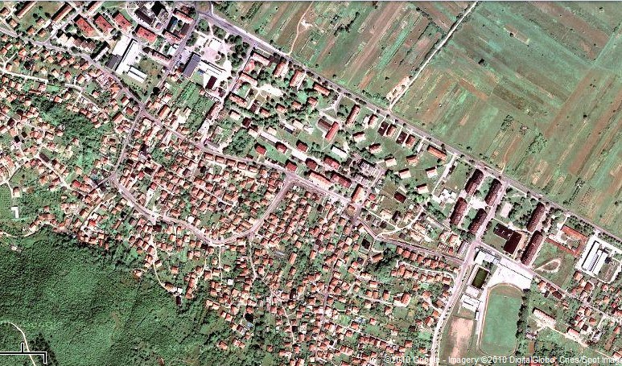
 |  |  | House |  | Sports centre

Whichever way you arrive, the best way to get to Hrasnica is via taxi. It should cost in the 25 KM region (or 12-13 Euros) from the bus station and about 20-25 KM from the airport. The best way to go about doing this is to approach a taxi driver with a piece of paper with “Hrasnica Dom Kulture” written on it (note: If you’re at Sarajevo airport, there should be a long line of taxis waiting for customers, approach the first taxi in this queue). It is strongly advised that you agree on the price before getting in the taxi, or alternatively ask them to turn on the taxi-meter (It has happened that they have over-charged before by 5/10KM). When you arrive, the taxi will drop you off somewhere near the community centre (Dom Kulture), it should cost roughly 1 KM per 1km. Or you can ask the taxi driver to drop you off directly at his house (the address is: Bunica 65). It is worth texting Nijaz before you arrive so he knows when and where to meet you. Don't worry if you arrive at an antisocial time; if you know beforehand, email him to let him know but still give him a ring as he will be expecting you. You can either arrange to meet him in front of the community centre or at his house (not advised since even most taxi drivers struggle to find it).
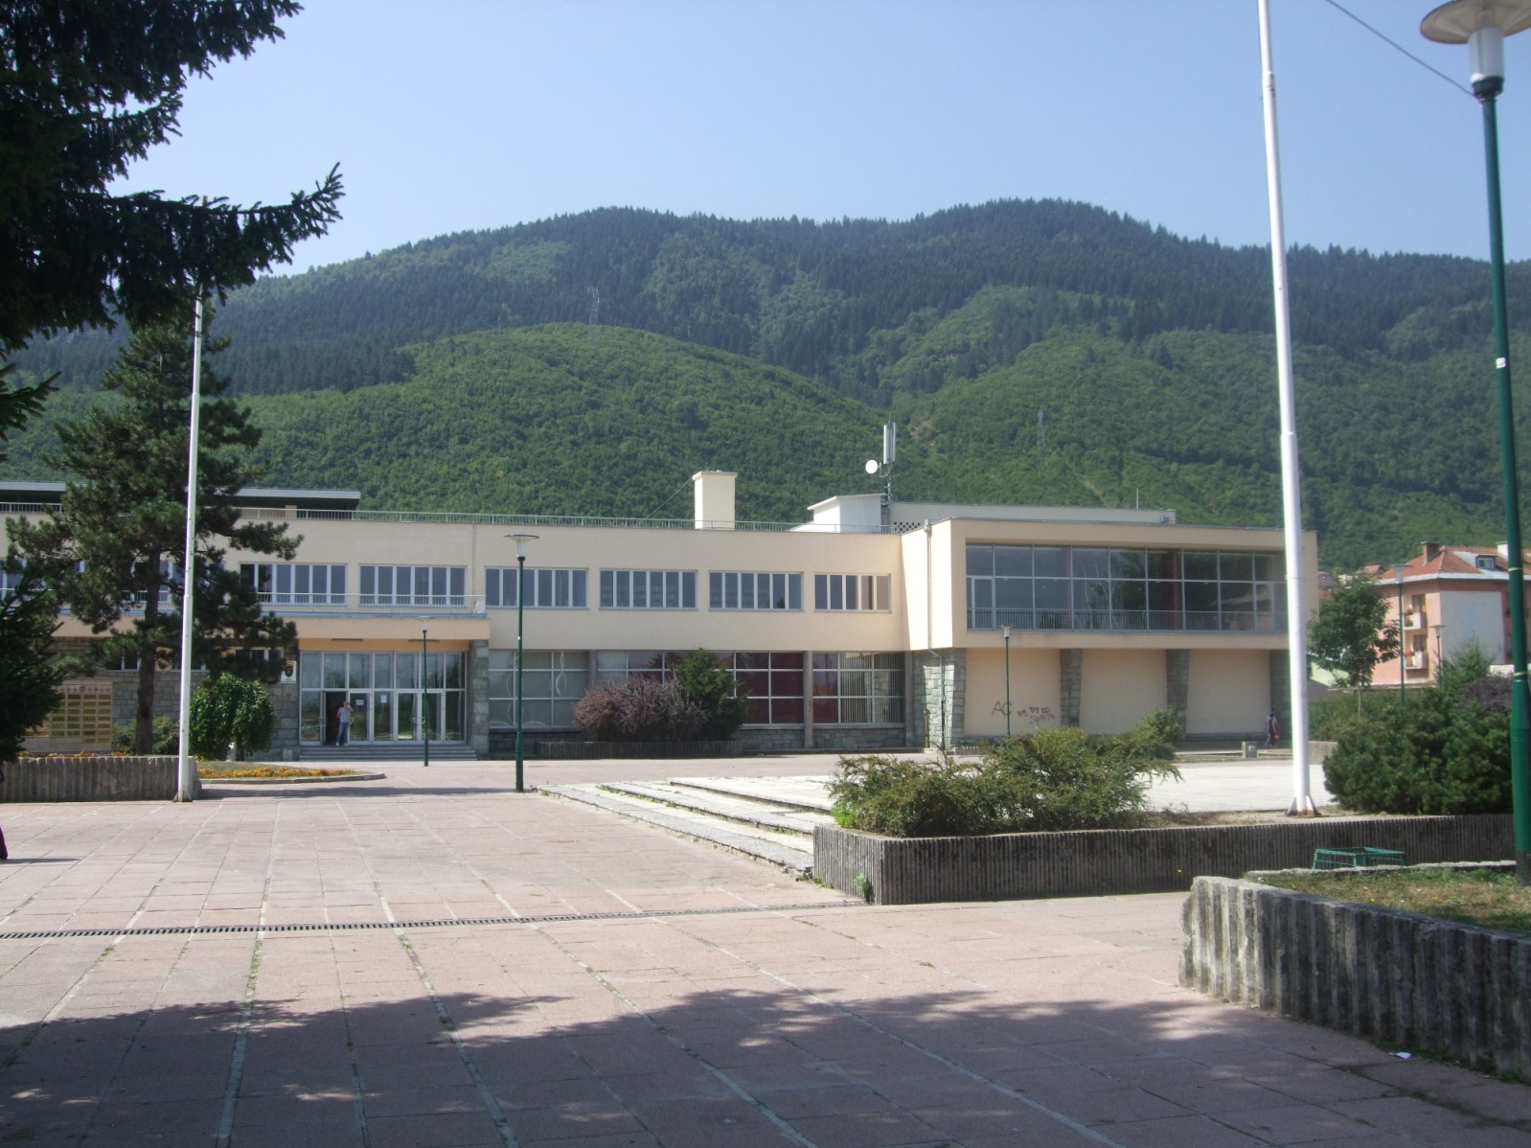  The front of the community centre: | 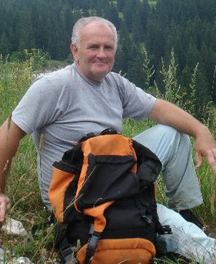  In this general area in front of the community centre is where Nijaz will usually wait for you. This is what he looks like just so you know.
Useful phrases
Hello (informal)..................................Zdravo
Good-Afternoon/Hello (formal)…Dobar dan
Good-Afternoon……………..……Dobro Jutro
Good-Evening………………………Dobro Vece
Thank you.............................................Hvala
Goodbye......................................Dovidjenja
My name is.................................Ja se zovem
Please...............................................Molim
How are you? (formal)………….Kako ste?
How are you? (informal)……….Kako si?

Contacts:
Nijaz Hrnjic: Head of community centre, +0038761838215, Bunica 65 (street, number)
nijaz.hrnjic@bih.net.ba
Note: his eldest son Armin speaks good English if necessary
Note 2: Remember you need to have a valid CRB/DBS check and have attended a volunteer training session before you go. You also need to have your own travel insurance.

Note: Similar to the “tu” and “vous” in French, you would use the “formal” to anyone who you do not know or who is older than you, and the “informal” for anyone who is younger than you.

Useful things to bring which are often forgotten (as well as the obvious):
- Lonely planet guide (or another travel guide)
- Phrase book (not essential but useful)
- Insect repellent and Sun-screen!!
- Trainers (spare)
- 2 bank cards (NOT travellers cheques)
- Raincoat + Long Sleeves + Jeans/Trousers; summer thunderstorms are fairly common and you don’t want to be caught out in torrential rain without a coat

Useful websites (for background information)
http://www.pixelpress.org/bosnia/context/history.html
http://www.pippins.me.uk/2009%20Bosnia/Bosniapics04.htm
Have a watch of this short film from Michael Palin’s trip to Bosnia. It was filmed in 2007 so things have changed slightly but most of it is still relevant
http://vodpod.com/watch/4370076-michael-palins-new-europe-bosnia-and-herzegovina
(There’s a mass of other information on the web about Bosnia and Herzegovina and it’s well worth getting an idea of the place before you go. In particular Wikipedia has a few, quite extensive articles about the recent war, which are worth having a quick read through just so that you’re aware of the recent history and it’s impact on the area)

About Hrasnica
It is a relatively small suburb of Sarajevo with a chain supermarket and many little corner-shops, ATMs and a bank to exchange money (the fixed conversion from Euro to KM, is 1 Euro for 1.95 KM, although it might be better to exchange money in central Sarajevo). Hrasnica also has many little places where you can have a quick lunch after volunteering, like burek (pastry filled with potatoes, cheese, or meat) or cevapi (pronounced chevapi – minced salted meat in flatbread with onions) or some other local (commonly meat) dishes; ask Nijaz or Armin to show you around – it is fairly easy. There is a great little Burek shop (called a buregdzinica) which sells fresh Burek every morning – a great, cheap breakfast to start off your day alongside a glassful of their Milky-Yoghurt, located just around the corner of the community centre, across the road from the supermarket under a large tree (If you’re unsure how to find it, again just ask Armin). They sell Burek by the gram and the recommended portion is 300g. There is also a bakery which runs almost 24 hours a day, located on the corner of the street with the shops, which is cheap but the bread and pastry can be a bit stale – Nijaz doesn’t speak too highly of it. Watermelons are incredible due to their hot summers and it’s great to finish the day sharing some watermelon slices, from the fridge, with the family if they want any. You can buy them in the local corner-shop just 40m down the road from the house.
It takes around 45 minutes to commute from Hrasnica, which is about 20 km away from town, to the old town of Sarajevo (called Bascarsija – pronounced Bashcharshiya). There are two ways of getting to the old-town:
- Via Bus; you first take bus no. 27 (not to be confused with bus no. 27 a or b, especially on the way back) from the cultural centre to Ilidza (a neighbouring larger town), there you change onto tram no.3 bringing you directly to the old city centre (you will see outside the windows the iconic fountain plagued with thousands of pigeons). Tram and bus tickets cost 1,60 KM (you can buy them directly at the driver – not recommended though, it is easier and cheaper to buy it from a little shop/stall/kiosk/corner-shop – if they don’t speak English say “Jedna karta za tramvaj molim vas” – One ticket for the tram please*** ), or you can buy a day ticket for 5 KM at a little kiosk at the tram station in Illiza. When you get on the tram you validate it by putting it in one of the machines. Note: The trams are known to be home to many pickpockets (and other odd people) so it’s advised that you travel in the front car behind the driver, and to keep all your belonging and bags close to you at all times although I’ve had a few really interesting and funny experiences riding the trams so don’t less this put you off. Plus they have that old socialist-Yugoslavia aesthetic which is nice to experience.
***I’ll go through pronunciation before you go
- The by far better option is to take the “Centrotrans” bus, which has “Vijecnica” on the front of the bus (if you’re unsure just ask someone or the bus driver), which starts directly across the road from the community centre by a small bus shelter. Each way it’s 2KM. On weekdays the buses go every hour (both from Hrasnica and the old-town) ie. 9am, 10am, 11am, etc. until 9pm, which is the last bus from the old-town!! (Although ask Nijaz, the last bus may actually be at 8pm!) If you miss it you may have to take the tram to Ilidza then the bus to Hrasnica (see above) or pay for a taxi – which isn’t that expensive anyway. It is important to note that on weekends the times the buses run changes. The buses leave Hrasnica at odd hours, and the buses leave Vijecnica (town hall) at even hours – ie. the last bus is at 8pm (Although again it would be best just to confirm this with Nijaz or Armin first). When travelling to the old-town, the stop you’re looking for is the last one, it should be located on a flat concrete parking area just behind town hall (called Vijecnica) which is easy to spot because it looks like a fortress painted with ridiculous burgundy/peach stripes.

About the Family:
You will be staying with Nijaz and his family in their home in Hrasnica. To avoid confusion and embarrassment with names, his wife is called Sabina, the eldest son is Armin and the younger is Ajdin (pronounced Aydin), and his daughter Ena. Just some background information: Armin studies chemistry at Sarajevo university, Ajdin is in secondary school and Ena is at primary school (she will be going to the sessions you organize). The washing machine is in the bathroom; just ask Sabina if you need to use it., she will probably do it for you. Ask Armin, the eldest son, for the Wi-Fi login details (Unless they have changed the password recently, the password is “nemainterneta”). They usually clear the top-shelf in the fridge in case you need it, Nijaz will probably explain this to you when you walk in the house. Nijaz loves occasionally having a few beers in the evening, which is a great opportunity to buy him a round of “Sarajevska” beers (the local Bosnian beer and “the best beer in the world” according to him) and a chill time to get to know him and have a fun chat. I strongly recommend you try to get to know the family and attempt to converse with them. Some of my best memories are the stories that Nijaz (and his family) told about what it was like in socialist Yugoslavia and during the war/siege. Not to mention that they can recommend the best places to drink Bosnian coffee, eat cevapi and all sorts of other things that you would usually miss!

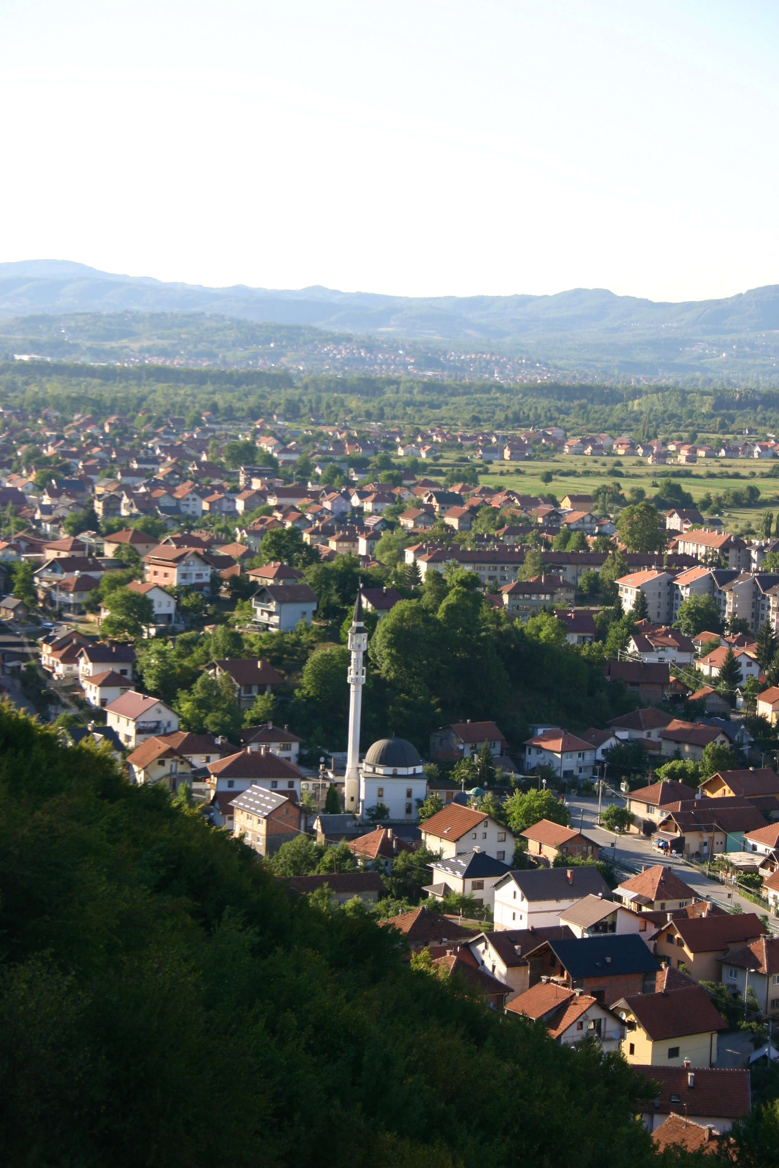 | 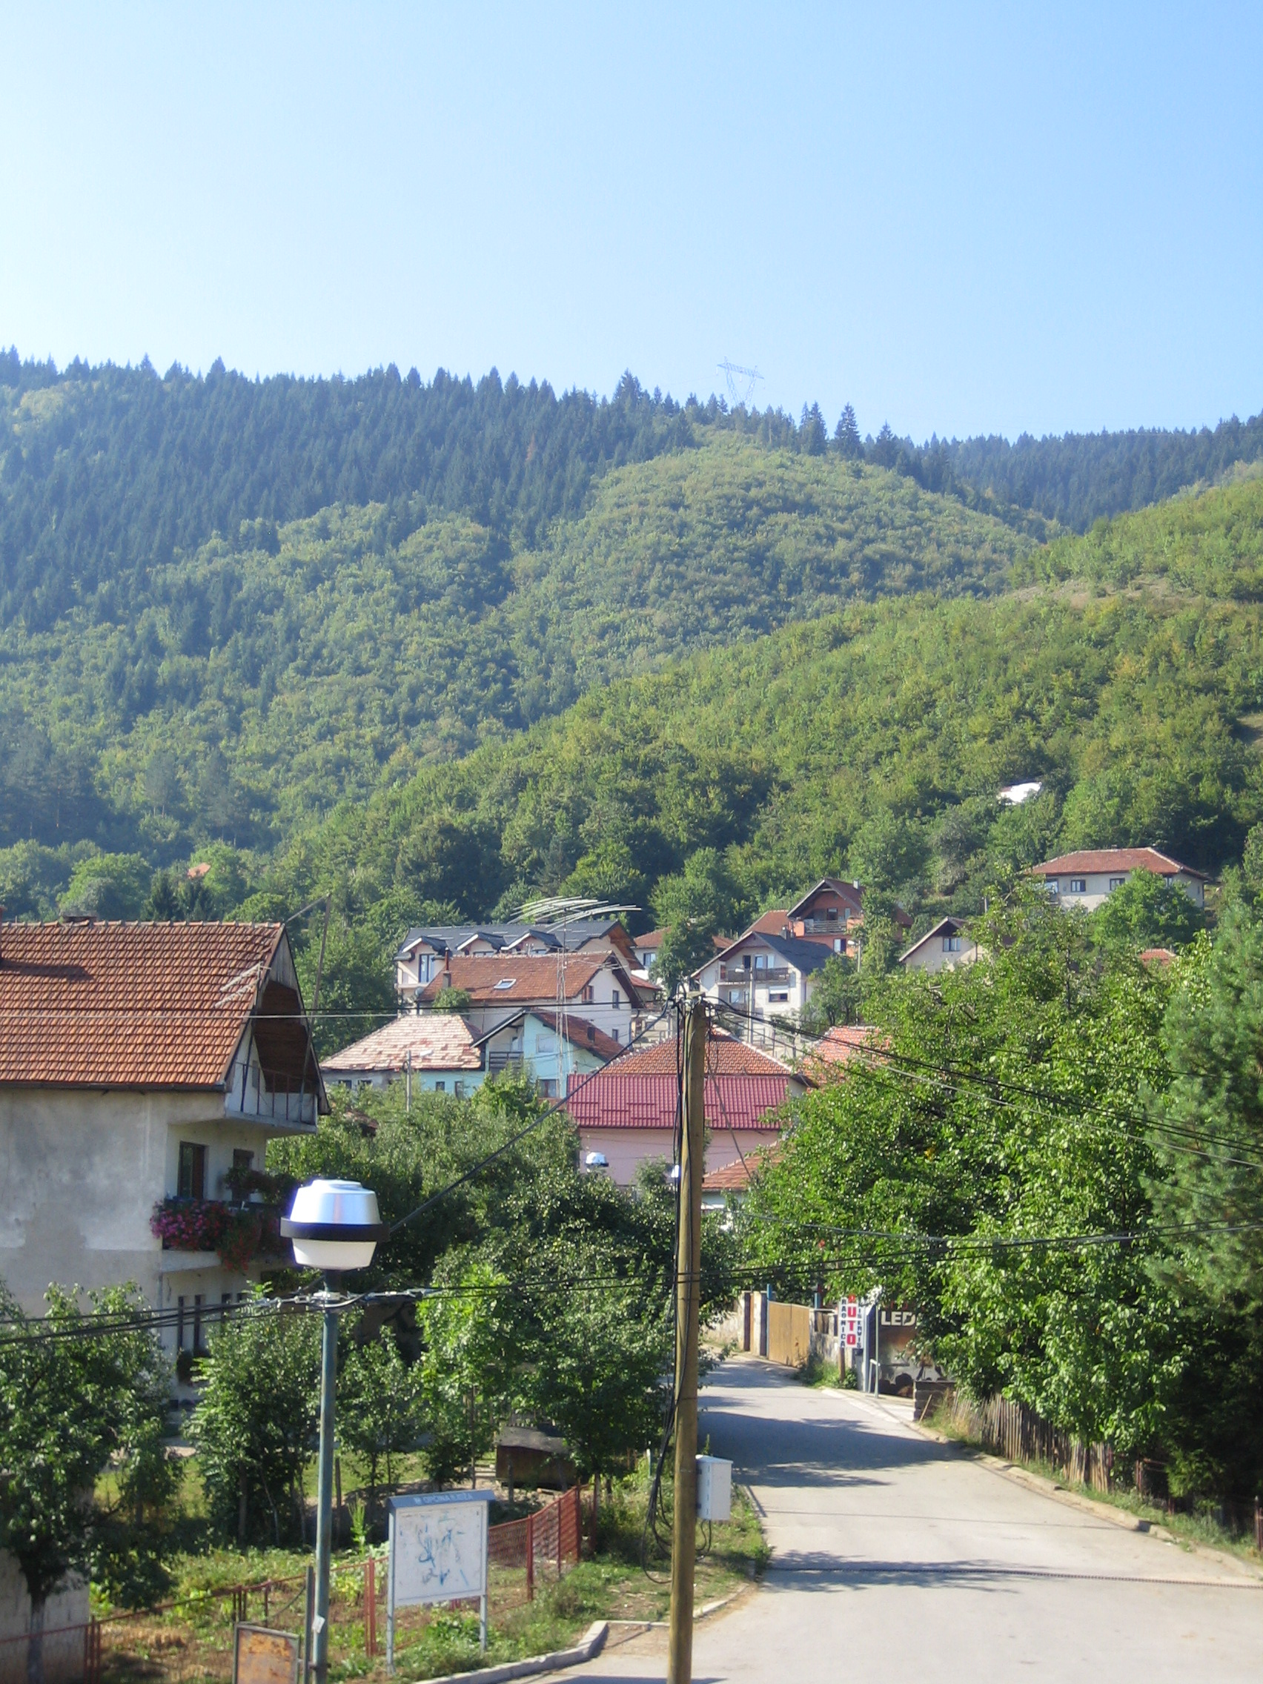
What do and see:
- Sarajevo is beautiful with its unique mix of mosques, churches, cathedrals and synagogues. In particular, the old part of town (Bascarsija) with its Ottoman architecture and cobbled streets is the highlight of Sarajevo. There you will find the best cafes, which serve Turkish coffee (although they call is Bosnian coffee) which is a must-try, and a few also serve Rakija – a very strong brandy made of various fruits which is considered a delicacy across all of Eastern Europe. You will also find the best restaurants there, almost all selling amazing Cevapi (I recommend the restaurant “Mrkva”) or Burek. note: you can to haggle with the market-stall owners when buying souvenirs and you can try to drive the price down by 10-20%! We found ourselves visiting the old-town almost every single day in the late afternoon and evening, trying something new.
- The Austro-Hungarian part of town which is divided by an actual line with the Ottoman part to show where “East meets West” and the contrast of cultures which cohabit peacefully in Sarajevo. Known for ice-cream, modern cafes and restaurants, the old town hall, the main cathedral and orthodox church, and a little park where pensioners play chess on a large plastic set and shout at each other – a great people watching exercise! This area of town is also where you’ll find all the bars, pubs, clubs, etc.
- Some interesting museums like the National History Museum (with a good exhibition about the siege of Sarajevo) but the one I’d recommend most is “Gallery 11/07/95” which has tours every hour explaining the recent history of Sarajevo and the cause of the wars.
- The museum of the “tunnel of hope” which was used to import food and supplies into Sarajevo when it was under siege. Nijaz has some incredible stories about going through the tunnel too! It’s a bit out of the way from Hrasnica so I recommend getting the taxi there or alternatively, quite a long walk.
- One of my favourite things to do was to walk up to the “yellow fortress” in the hills at sunset, especially during Ramadan when all the minarets light up at sunset and a canon shot is fired to signal the end of the day. It’s really beautiful!
- A must is a walking tour of Sarajevo, which gives insight into the current politics and recent history of the area and many other fascinating anecdotes. I recommend “Neno’s walking tour” which can be booked/looked into on “sarajevowalkingtours.com” – a 2-3 hour walking tour on Sunday mornings led by a very funny man Neno or his friend, who lived through the siege and have stories to tell themselves.
- A nice day trip is Mostar (2h30 by bus or train) known for its iconic bridge (a UNESCO World Heritage site) and the brave divers who jump off of it. Ask Nijaz to see if there will be any bridge-diving tournaments/competitions when your there, but there will almost always be someone jumping off if you go.
- While visiting Mostar, if you decide to stay for a night, you can visit the nearby “Kravice” waterfalls which are stunning and a very popular attraction. They’re a bit of a pain to get to so unfortunately I made it, but I’ve heard they’re well worth the effort. Getting there is explained on: https://onestep4ward.com/visiting-kravice-waterfalls-bosnia/
But ultimately, in short, you’re going to have to shell out a bit of money for either a tour or a taxi since there isn’t really any other option. I’ve heard it was the highlight of many people’s trip though.
- A slightly further trip is to Jajce, which is a medieval, fortified city with a popular waterfall and a very pretty, long lake that is perfect for swimming on a hot day. The buses take 3-4 hours and they aren’t very regular, so you’d have to book a room in one of the two hostels in Jajce.
- In Illiza there is a nice walk through a 3 km long alley leading you to the spring of Bosna (Vrelo Bosna), which is situated in a small park (you can also take a horse carriage for 15 KM bringing you there). It’s quite a pretty park but I’d recommend it if you have run out of other things to do/see.
- Illiza also has the Termalna Rivijera a big swimming park with many pools, whirpools, slides, etc. (about 12 KM/day)
- You can also look into a day-trip to the Bosnian sea-side. Bosnia literally has one small city which is by the sea, located very oddly between Croatia if you look on the map, but there are tour companies which offer a round trip to the beach, usually leaving Hrasnica at 3am and leaving the beach at 7/8pm, for the cheap price of 25KM round-trip. Probably best to ask Nijaz/Armin for help in booking this.
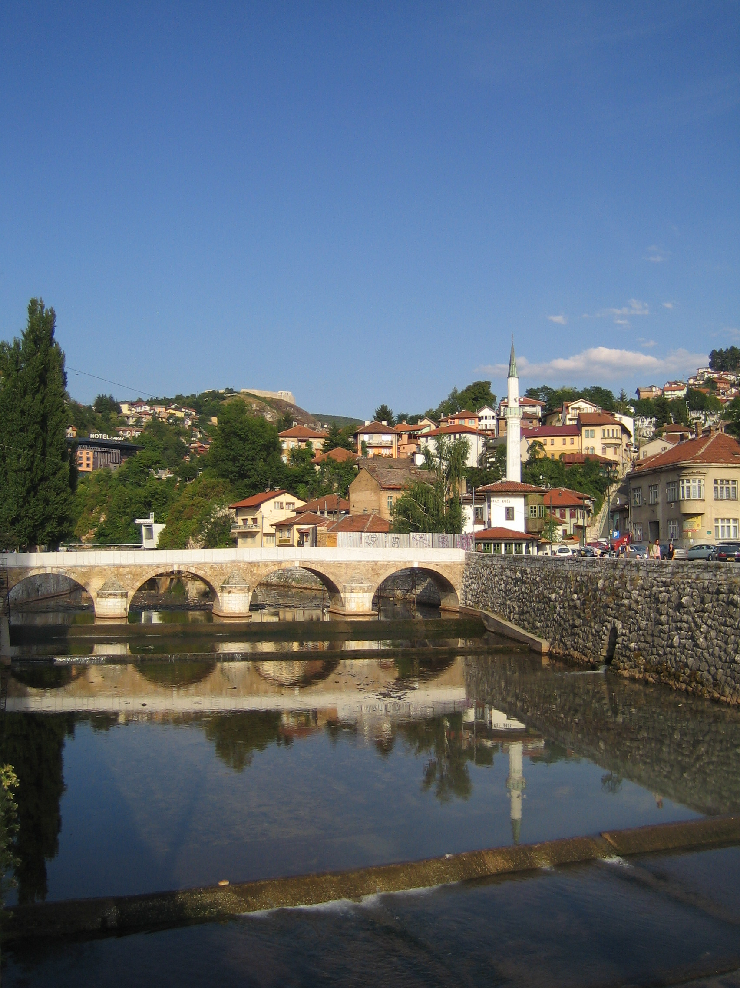  Sarajevo | 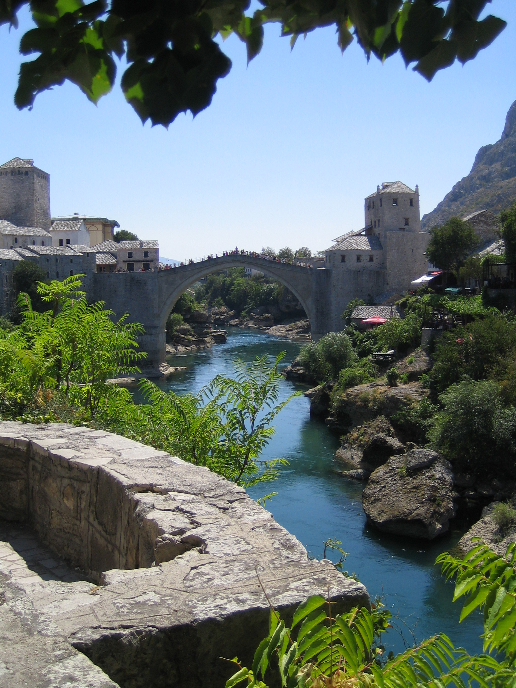  Mostar
Health and Safety:
- There are no particular travelling precautions required that are unique to the Balkans; be vigilant as you would be anywhere, but as long as you take care, Bosnia is a safe and pleasant country to travel in.
- We advise you to be careful with your possessions and to keep your valuables on you so there is no risk of anything getting stolen. (Be aware of the possibility of pick pocketing, especially on public transport or when walking/sitting down in a busy area.)
- Hrasnica was mined during the war, and due to floods some of the landmines were not recovered/found so it is best to check and ask Nijaz first if that area is safe to walk through first. Although almost always these areas are large, neglected fields so you wouldn’t find yourselves in any danger unless you went exploring in unpopulated areas.
- We advise you not to go off on your own, especially at night. Bosnia is usually safer than England at night but obviously as a foreigner it’s not worth the risk.
- If you decide to go somewhere alone inform other members of the group where you are going.
- Be sure to carry a mobile phone with you so you can make emergency calls.
- Ensure that you know each other’s mobile numbers so should you get lost you can contact each other.
- It is likely to be hot, so drink plenty of bottled water to avoid dehydration and heat stroke. The tap water in Hrasnica is safe to drink since it’s from the local spring
- Make sure to wash your hands before eating or handling food.
- Avoid contact with stray or domestic animals (Treat bites immediately by washing with water and soap, and seek medical assistance). You will see an alarming number of stray dogs particularly, often in packs. Some are very friendly and gentle but it is best to avoid them as a precaution. They are rarely aggressive/attack if unprovoked.
- We advise you to apply insect repellent in the evenings or when in the forest, as well as to wear sun protection, sunglasses and a hat to protect yourself from the sun.
- Vaccinations for Hepatitis A, Hepatitis B, Typhoid, Rabies, MMR and Tetanus-diphtheria are all standard vaccines which recommended but certainly not compulsory, check http://www.mdtravelhealth.com
What to take
Although Nijaz himself has said that it is not worth brining stationary, knick-knacks, etc. since it is often lost/stolen or not reused, if you do plan on taking things it often is a lot cheaper to buy things in the Balkans and this also saves on packing, but it may be more difficult to get certain things. Bring anything slightly unusual that you need for activities with you from England. Where you can get some of the other material: the supermarket at Ilidza (the tram station, which you change at from the bus in order to get into town) and stationary shops in the Austro-Hungarian quarter of central Sarajevo. And there is usually a lot of material left in Nijaz‘ office from former OXAB volunteers, although many pens are old/dry.
For example:
- Frisbees - they are rounders bases, sequin holders, paint pallets, useful in water-fights and you can throw them!
- Water Balloons – especially during the heat-waves, water-balloon fights are extremely popular as an extra-session run after the main one
- Bubbles
- Playing cards
- Coloured pencils/pens; anything else to decorate
- All sorts of stickers (maybe themed, like for Easter, Christmas, birthdays …)
- Little prizes for games (they love chocolate by the brand “Kinder”)
- Coloured and white paper
- Glue sticks
- Skipping ropes, balls, and bats
- Any old fancy dress stuff
- Blue tack for putting the children’s work up, as they enjoy looking at it
- Any old games or puzzles you may have at home
- Bosnian - English pocket dictionary
- Don’t forget a travel adaptor! (standard European socket)
Working with the children:
- Overall you should find working with the children a positive and rewarding experience. Beware that you and the other volunteers will be alone with the children; but Nijaz can usually be found in his office in the community centre upstairs, or wandering around outside in front of the community centre in case of any problems.
- If you do have problems with behaviour at times, do not take it as any reflection on how you are looking after the children - this is perfectly normal and you mustn’t forget that these children have sometimes very difficult backgrounds. If the children do misbehave, make sure you stay absolutely calm and firm. If you overreact this will only provoke them to be worse! If a scuffle does happen to breakout, separate them as soon as you can and get Nijaz to ask the children what happened in case they can’t explain it to you. But you may want to consider sending them out or telling them that they are free to go home, as it is not mandatory for them to attend the session; this usually is very effective!
- The number of children at each session every day varies greatly from 8 to 25. Splitting the kids into two groups is helpful for some activities (the shyer ones tend to get drowned out if you don’t, and they’re more manageable that way); some of the boys can be quite disruptive if allowed to stick together - if you can, try to split them up. The best way to go about this is to offer an outdoor and an indoor activity with at least one volunteer running each. Often you will find the children will prefer the outdoor activities and at times they will all wish to be outside – but they are often easier to control during large group outdoor games anyway.
- You’ll probably find sharing can be a problem among the children and equipment you bring can disappear mysteriously. Make sure that you have plenty of stuff to go around and keep an eye that the children are sharing nicely. Often the most successful activities don’t involve lots of equipment that could be fought over.
- Do not pay special attention to any one child / discriminate between children (you will often find that particular children become very clingy / seek a lot of attention, make sure that this doesn’t lead you to forget the others).
- The language barrier tends to be less of a problem with the younger children and within a few days you’ll be amazed at how you can communicate with them. It can be more of a problem when trying to communicate with older children. If there is an older child/adult who speaks some English, get to know them as they can be really helpful if you want to organise things / have problems. Thus, as the older ones usually take the role of translators, allow them to do this, and don’t talk over them. A lot of the children are a little reluctant to speak English, but seem to understand quite a bit. update: the very young ones probably don’t speak any English at all (ie. below the age of 7/8) and so communicating with them is a bit of a problem.
- You’ll sometimes find the older kids will be less interested in your activities. However, if you can, get to know the older kids and maybe organise a special activity for them. Don’t forget that the older children are in just as difficult a position as the younger ones and will enjoy getting to know you. If you do get on well with the older children, it’ll improve your working atmosphere and they can be very useful for sorting out problems with the smaller children.
- It often works quite well to wear a name badge, as it helps the kids to get to know you and your possibly unfamiliar name. This could also be a possibility with the children, as different people tend to come on different days. (You could make an activity out of it and create artistic name badges for everyone although this only keeps them interested for about 10 minutes).
- The children love cameras and will really enjoy having their photo taken. But be careful to set up clear boundaries regarding use of your camera and check that it’s ok with the staff first (also remember not to put any pictures of the children up on facebook without permission). A nice leaving gift could be a collage of photos of the children for the centre (make sure you get photos of everyone!). Past volunteers have also said that giving cards to each child when they left was really successful.
- You are responsible for your own belongings (establish ground rules with the children, e.g. carry a bag that is out of bounds to them)
- Do not give money to the children. If you want to make a donation do not give money directly to the staff. Even if you trust them, you will often find the money won’t end up going where you want it to. If you want advice about spending, just get in touch with OXAB.
- Overt language instruction is hard to do - they much prefer games! And it is their summer holiday... so do not try go through exercises like in school but think of activities which could integrate new vocabulary with games – it is best to promise to do something they like if they go through your more educational exercise first. They quite like learning new games that have a song attached to them, or children’s nursery rhymes which are easy to remember.
Activities
Generally, unless it’s raining, the most successful activities and games are those that are played outside. This can be either the sports centre, or more commonly just outside the community centre. The children have to patiently sit in school all day, so during the summer it is the last thing they want to, and will, do. Don’t be surprised if the children don’t do the activities you set/planned out for them, this is often the case and what worked best was to start with an outdoor game that children could join in to as they arrive (if they were late). This is also before the scorching mid-day sun. By far the most popular games were hide & seek tag (called “Zmire” in Bosnian), Cops and robbers, chain tag and also stuck in the mud. Then we took the children inside for a breather and for us to all cool down with one of their favourite indoor games which they voted on; usually blind man’s bluff, musical chairs, duck-duck-goose, or hanky-panky (they will teach you this one if you don’t know it). Before ending the session with another outdoor game (usually just a repeat of hide and seek tag as this is their favourite game – especially when one of you hides and the other seeks). If in doubt about what to play, just ask them and let them vote. It also worked quite well when there was disagreement, to split them into two groups and offer an outdoor activity and an indoor activity. The majority of them will rather play outside but there will be a few of the usually shyer ones who wish to draw or do some arts and crafts inside with one of the volunteers. Don’t worry too much about the children playing in the heat – they are used to it and cope with it far better than you do! Although it has happened before that Nijaz has restricted activities to indoors due to heat-waves, so it is best to look at the weather forecast before you go and plan accordingly.
If you have nothing planned that afternoon (or decided to delay the bus-ride into Sarajevo till 4 or 5 when the air-condition-less bus is more bearable/less life-destroying) what is very rewarding and great fun is to continue playing with the children in the neighbourhood. They’re not bothered about what game you suggest, they just want to spend time with you and get to know you – although water-balloon fights on a hot day is a crowd-pleaser (note: you will probably end up spending 5-10KM or so on water balloons each time!)
Some other general points (some are repeated):
- Making a rough plan of your activities is good (so you don’t run out of things half way through). You may want to repeat activities that you find are particularly successful. As you get to know the kids, you may find it is most successful to run different activities at the same time with smaller groups. Don’t worry too much about how best to organize it. It will become obvious to you as you go along.
- A good first every activity is to make name badges/stickers. Although you’ll probably forget by the next day, attempt to learn all their names if you can manage. Usually best just to bring a sheet of white labels and have them write their names on. This takes a lot less time than you would expect as they’re not too bothered about decorating them – approx.. 5 minutes.
- A very useful tool to have in the tool-belt is Hide-and-Seek-Tag. When there’s an argument or some sort of disruption brewing the easiest way to resolve this is to round up all the children by shouting “Zmire!” and getting all the children outside.
- Activities that have a clear result / finished product often work best as the children have something to work towards and concentrate better.
- Be ready to improvise with your activities, sometimes you’ll find the children aren’t as interested as you expected them to be, or if a few children are playing up it can be good to have another activity to distract them with and take them away to do. Keeping e.g. a pack of cards and threads for friendship bracelets in your bag for emergencies can work well.
- The kids also love activities that don’t require any preparation, e.g. Thumb wars and clapping games (learn as many as you can!) go down really well. Remember it is attention that these kids want and need and you can provide this without extensive structured activities.
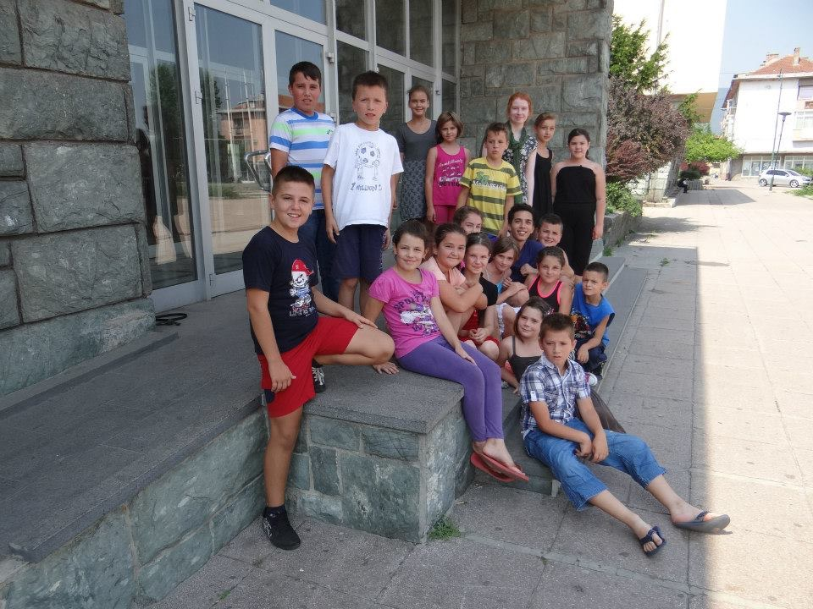
- Make sure you stay after the session and tidy up after your activities; the staff will not appreciate mess everywhere!

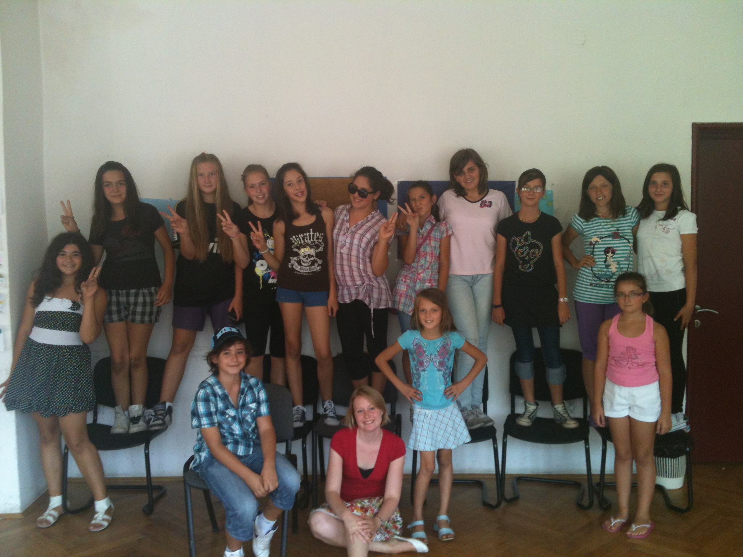
The possibilities are endless, but here are some activities that have worked well for volunteers in the past:
- Parachute if one is available
- Musical chairs - they love this (can be helpful in stopping fights)! Quite a challenge to stop, so we tended to do this at the end, in the final 15 minutes. They organise themselves.
- Duck, duck, goose.
- Banana song
- Making name cards and presenting each other
- Studying and singing pop songs (ask which Anglophone groups they like)
- Sentence games (sit them in a circle and each says a word in order to form a full sentence)
- Broken Telephone
- Team-based games such as Town/ Country/ Profession/ Animal where they have to fill in starting with a specific letter (works well with a final prize for the winner as incentive)
- Wink Murderer (finding out who the murderer is)

Arts and Crafts
Although relatively unpopular with the majority of the children as they are simply too impatient to sit down and create/draw something, and you will often end up with a small riot on your hands with little pieces of paper and glitter absolutely everywhere. If you manage to separate a smaller indoor group then here are some ideas:
- Drawing pictures (sometimes you might find children struggling to think of what to draw, try looking in the dictionary and writing a word in Bulgarian/Bosnian at the top of sheets of paper (e.g. “dog”, “airplane”, “garden”) this can help and in general makes it a more focused activity which the children concentrate better on)
- Name badges/notebooks (you’ll need: big white stickers or exercise books; big marker pens; stickers, sequins, glue, glitter gel, colouring pencils: anything they can easily attach and decorate with. Just let them get on with it - do some example ones with different patterns etc)
- Butterfly pictures (you’ll need: large sheets of paper; poster paint. Do a set of examples one of only half the painting to show that it is folded over to finish; emphasise working quickly so the paint doesn’t dry, then let them add embellishment with sequins etc (any resources used in a few different crafts like this is good))
- Flower pictures (you’ll need: large sheets of paper; tissue paper. Draw an outline, then fill in the petals with rolled up tissue can be quite laborious! For those who bore easily, get them to cut out and stick the tissue on each petal instead.)
- Collages (cut up lots and lots of magazines and comics, so you have pictures of cars, animals, pop stars etc. This activity often goes down really well as everyone can join in and pick their favourite pictures)
- Jewellery and friendship bracelet making (embroidery threads and beads work well for this) Boys often enjoy this one as much as the girls
- Paper-plate masks
- Fancy dress (with scraps of material or newspaper)
- Face-painting
- Painting big posters
- Water colour paints (less potential for mess than poster paints!)
- Making pom-poms
- Pavement chalk
- Sand art
- Making customised t-shirts
- Making playdough
- Potato/finger painting
- Simple origami (try making the chooser things. The little kids like playing with them, and the older kids enjoy the game if you can put Bulgarian words inside, e.g. beautiful, funny, silly)
- Paper plane races
- Cutting out snowflakes and chains of little men
- Sock puppets
- Making instruments out of boxes
- Peg dolls
- Flower pressing
- Pasta necklaces
- Pasta necklaces (you’ll need: coloured pasta (can either be dyed with food colouring or buy tricolore!); String. Tie a knot and get threading, they can try out different patterns. To add some more decoration, have ribbons they can tie on.
Games and sports
- Card games -very popular especially with the boys. Snap works well, but they might want to teach you their own games, though a bit hard to play in larger groups
- Bingo (easy to play if you learn a few Bulgarian / Bosnian numbers, or you could play in English and make it into a language exercise to teach the kids English numbers)
- Jigsaws - Provides a welcome break as kids sometimes concentrate really hard on them
- Frisbee
- Badminton
- Bouncy balls
- Younger children especially enjoy games like “What’s the time Mr Wolf?”, “Grandma’s Footsteps”, “Duck, duck goose” (always very very popular!), “Red Rover” “The Hokey Kokey”, “Oranges and Lemons”, “Here we go round the mulberry bush”, “Hanky Panky” (it’s oddly named since I don’t think they know what this means but ask them to teach you how to play!)
- Dance routines
- Football, Volleyball, Basketball, Handball, …
- Flying kites
- Obstacle course
- Skipping
- Dodgeball
- Hide and Seek Tag or Standard Tag (endless variations!)
- Chalk courses
- Hide and seek
- Treasure Hunt
- Paperchase
- Nature Trail
- Egg and spoon race
Party:
- The kids love having a party and it gives a nice end to your visit. Check with the staff before you go ahead and make sure there is a space you’re allowed to use.
- Just a heads up, the party itself usually lasts for only half an hour as they’re keen to continue playing outside.
- Involve the children in planning and preparing for their party. Activities sessions before the party could include making paper chains and making party hats. Though, again, they would much rather play some outdoor games than sit down doing arts and crafts.
- Sweets and fizzy drinks make a nice treat for the kids at the party (but confirm with the staff that it is ok to provide food). Nijaz and the staff would prefer food which is not too messy and easy to clean up after e.g. haribos and what not.
- If you’re really keen you can set up some party music and balloons
- Games that go down well include musical chairs, musical statues, musical bumps, duck-duck-goose.
- Note: Only small prizes for the games as some of the children get jealous and can’t share

I hope this was helpful and answered any questions you may have had. If there’s anything that was missed out or for more specific queries feel free to email me at: oxabinfo@gmail.com

