OXAB Projects 2017

Albania
OXAB has sent volunteers to Albania for the last six years where we work in partnership with a Swedish NGO called TAMAM (which means very good/fulfilled in Albanian) who run a ten day summer camp in the village of Marqinet, near the capital (Tirana).
On the 15th of March 2008 a chain of explosions at an Albanian military depot situated merely twelve kilometers from Tirana carved out three deep craters in the earth only metres away from the villages of Gerdec, Martinet and the small town of Vora. The initial blast combined with the subsequent falling debris and artillery ordinance wreaked havoc upon the lives of more than 6,000 people, leaving in its wake 26 dead, more than 300 injured and hundreds of homes and businesses destroyed. Help from aid agencies such as Save the Children was plentiful during the immediate aftermath, however their presence was very much transient, leaving only TAMAM behind. What TAMAM realised was that long-term support was needed for the children of Marqinet, and thus a long term project was initiated in collaboration with students from the University of Tirana with an aim to integrate marginalised youth into Albania's broader socio-economic and political spheres of life.
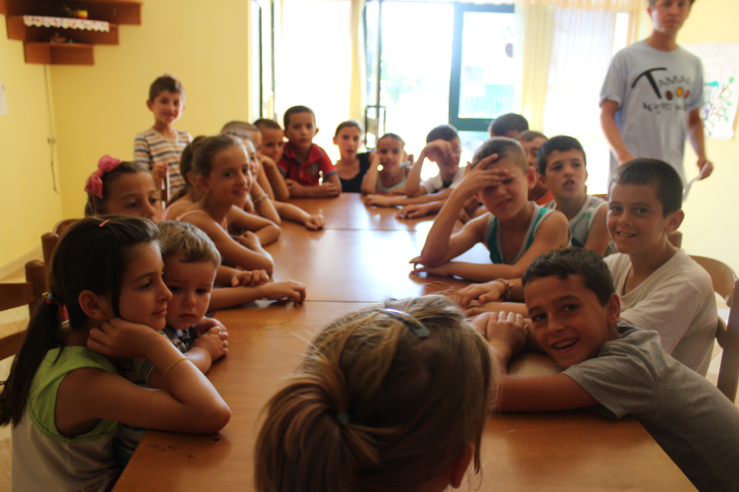
The highlight of the year for the children is always the summer camp which is attended by between 60-100 kids each year (all between 6-15 years old). Each day there are 6 hours of activities per day (sports, arts and crafts and English lessons) as well as excursions such as trips to the local swimming pool or the beach in nearby Durres. Volunteers are encouraged to socialise with each other to facilitate a cultural exchange, with themed events and trips organised every evening. On last year’s trip there were volunteers from Denmark, Sweden, the USA and Korea (in addition to the OXAB volunteers) which reflects on TAMAM’s motto; ‘friendship without borders’. Food and accommodation are provided for the duration of the camp as part of a £150 camp fee and volunteers live and cook together in rented apartments.
Unlike our other trips, our Albania project has fixed dates (usually from early to mid-July) and we are limited by numbers so can’t guarantee all applicants will receive a place if demand is high (usually we are unable to accept more than 4 volunteers).

Bosnia
OXAB have been organising aid to refugees in and around Bosnia-Herzegovina (BiH) ever since the war in the early 1990s, and unlike many other charities which have moved on to more recent flashpoints, we continue to help those affected by the conflict, two decades on. The country was torn apart by the war, with huge flows of refugees as communities with a mixed ethnic background were violently separated into their constituent groups, by various militias and armies engaging in “ethnic cleansing”. Needless to say, the war also resulted in the deaths of thousands of people, from all ethnic groups, leaving many people, including children, without family or friends. The need for aid continues to be felt by children growing up in a ravaged and very poor society. OXAB provides volunteers to run sessions in the community centre, without which there would be nothing for the children to attend during the holidays.
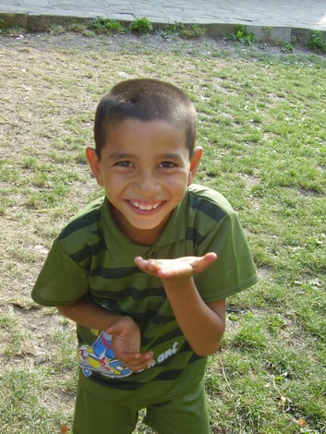
Hrasnica Community Centre, Sarajevo
The Community Centre (Otvoreni Centar) in Hrasnica, a suburb of Sarajevo, is the only place in the town for young people and children to spend their free time without being on the streets. Through a combination of educational and recreational activities for children, the centre is able to provide Art, English and IT classes, as well as health advice for the prevention of alcohol and drug abuse. Although the centre is equipped with materials and activity packs for the children, this comes almost entirely from contributions from previous OXAB volunteers. All money raised by our OXAB Bosnia volunteers goes directly to the Hrasnica community centre, allowing our volunteers to have a direct impact on children's lives, both in the short run as volunteers and in the long run through fundraising.
During the morning volunteers are free to organise sessions with the children and they have access to a classroom and the sports centre. Generally the sessions run from 10 am to 12/1pm. During the afternoons volunteers are free to explore the area or if they like can provide more sessions for the children.
Bulgaria
OXAB has been operating in orphanages in Bulgaria since 2001 and it is our longest continuously running project to date. Our work in Bulgaria is based around helping children in orphanages, street children's centres and other institutions.
While most of our trips are to orphanages, these vary enormously in the conditions for the children and in the abilities of the children in the institutions (one of our projects involves helping with children with moderate disabilities a day care centre). For this reason likely activities depend very much on the children’s age and ability. While with some placements, especially the street kids’ centres, you might be organising sports and other outdoor activities, or, for example art, drama, or even English lessons, in others the children will be less able and less active, and so your work would be restricted to more basic interaction, and to helping the staff with work around the centre.
Volunteers play a crucial role in giving the children much-needed attention and organising activities during the otherwise unstructured school holidays. In general, the language barrier is a relatively minor difficulty and OXAB provide you with language lessons and information before you go. We have English speaking contacts in Bulgaria who arrange placements, accommodation and arrival at the orphanage and who act as a point of contact throughout the trip.

Balvan Orphanage
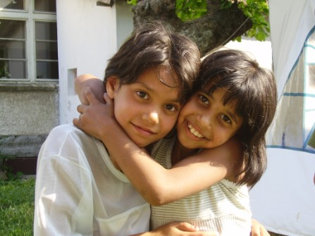
The Balvan Orphanage is situated in a small town around 15km from Veliko Tarnovo. During the summer there will be around 30 children in the orphanage between the ages of 4 and 17, although occasionally there may be teenagers up to the age of 20 who are staying at the home whilst they finish their studies. The largest proportion of children will be primary school age (and go to the primary school in Balvan) and so activities should be planned accordingly.
OXAB’s long term projects – the Children’s Club and the Mentoring Project – are also both located in Balvan, so OXAB has a large presence in the village which volunteers can also get involved with.
Balvan Crisis Centre
The Balvan Crisis Centre is situated next to Balvan Orphanage (they share a playground) and it cares for girls aged 9-18 who have experienced sexual or physical abuse. Volunteers are in high demand and are welcomed here by the girls, although this can be a more challenging experience compared to our other trips and we would therefore only recommend more experienced volunteers work here. As the crisis centre is quite small, we would also suggest that volunteers go out in groups of two as opposed to three or four.

Gavroche Orphanage (Varna)
Gavroche is located in Varna, Bulgaria’s second largest city on the Bulgarian Black Sea coast, so volunteers can travel directly there either by plane or by bus or train from Sofia.
The orphanage (http://www.gavroche-bg.org/eng/index.html) takes a majority of Roma children from the Varna area and some will have difficulty speaking Bulgarian. The children attend classes until lunchtime each day and are free in the afternoons. The care workers run an outreach programme at the same time every day to try and attract more children to attend the centre. They offer the children a change of clothes, food, and a doctor’s examination, and they encourage them to attend the local state school. In the afternoons the care workers help the children prepare for their school lessons. The activity programmes that the centre runs include sewing, woodwork and painting. The centre looks after around 25-30 children per day (in the summer there are more), aged 5-15yrs. They are free to come and go as they please, but the door to the centre is closed after 10pm.

As our connections with this orphanage aren’t as strong as with the others (and it is located quite far away from our in-country contact) we would only advise volunteers expressing a preference for Gavroche if they are confident in organising a large portion of the trip independently.

Gorna Orphanage
The orphanage in Gorna (near Veliko Turnovo) is one of the Bulgarian government’s new day care centres and an attempt to move away from the traditional institutionalisation of disabled children and adults. The centre was set up in 2006 to provide day care for children and adults, who could then go home to their families in the evenings or at weekends. This kind of system is a rarity in Bulgaria, where attitudes towards disability are much more problematic than in Western Europe (and is therefore something which needs to be encouraged). Until 2008 the children and adults were mixed, but there have been renovations, and the two groups are now housed in neighbouring buildings. There are permanent German volunteers working with the adults, so OXAB volunteers will work with the children of which there are approximately 30, all with moderate disabilities.
Gorna Family Centre
The Gorna Family Centre is a small orphanage we have recently started working with. It is a centre for disabled children. This centre would only be suitable for volunteers who would feel confident in working with children with more severe disabilities. In this Family centre the children have no parents and require a great deal of support.

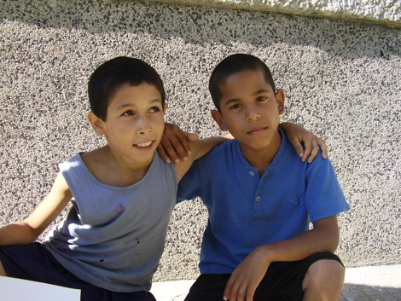
Veliko Tarnovo orphanage
The Penyo and Maria Velkovi Orphanage is located in the heart of Veliko Tarnovo and is the biggest institution we support, serving as home to 55 children. The institution has been newly renovated, has 3 floors along with a kitchen, dining room, living room and bedrooms for the children. Volunteers stay in the home of an old couple, Margarita and Ivan, who live across the road from the orphanage and rent out their rooms to students.
Veliko Tarnovo Family Centre
This is a new residential institution for orphaned children, aged 6-18 which hosts around 10 children. The family centre is essentially a small house, with 2 bedrooms and other basic amenities and the atmosphere of a family home.
Any questions? Don’t hesitate to get in touch with our country reps:
Albania: natalie.clarke@keble.ox.ac.uk
Bosnia: filip.muncan@wadham.ox.ac.uk
Bulgaria: dylan.vignola@univ.ox.ac.uk

For more general enquires you can also email us at oxabinfo@gmail.com

